What Is Programming?
Television shows and films often show programmers furiously typing cryptic streams of 1s and 0s on glowing screens, but modern programming isn’t that mysterious. Programming is simply the act of entering instructions for the computer to perform. These instructions might crunch some numbers, modify text, look up information in files, or communicate with other computers over the internet.
All programs use basic instructions as building blocks. Here are a few of the most common ones, in English:
“Do this; then do that.”
“If this condition is true, perform this action; otherwise, do that action.”
“Do this action exactly 27 times.”
“Keep doing that until this condition is true.”
You can combine these building blocks to implement more intricate decisions, too. For example, here are the programming instructions, called the source code, for a simple program written in the Python programming language. Starting at the top, the Python software runs each line of code (some lines are run only if a certain condition is true or else Python runs some other line) until it reaches the bottom.
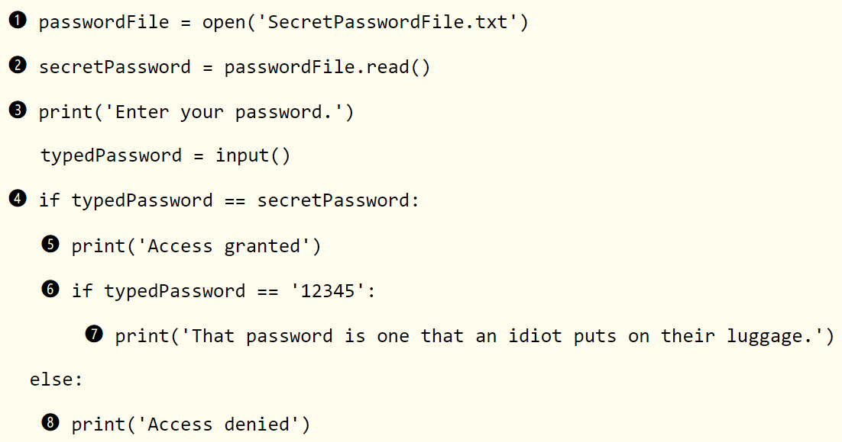
You might not know anything about programming, but you could probably make a reasonable guess at what the previous code does just by reading it.
➊ First, the file SecretPasswordFile.txt is opened ➊,
➋ and the secret password in it is read ➋.
➌ Then, the user is prompted to input a password (from the keyboard) ➌.
➍ These two passwords are compared ➍, and if they’re the same,
➎ the program prints Access granted to the screen ➎.
➏ Next, the program checks to see whether the password is 12345 ➏
➐ and hints that this choice might not be the best for a password ➐.
➑ If the passwords are not the same, the program prints Access denied to the screen ➑.
Quelle: https://automatetheboringstuff.com/2e/chapter0/

